**ASSIGNMENT NO. 2**

**Aim:** Write a C program to print Fibonacci sequence up to n terms.

**Objective:** To understand the logic behind Fibonacci series which is it is a series of numbers where the current number is the sum of previous terms and hence printing it up to n terms.

**Software required:** Online GDB Compiler

**Theory:**

For loop – It is a control flow statement for specifying iteration which allows code to be executed repeatedly.

**Flowchart:**

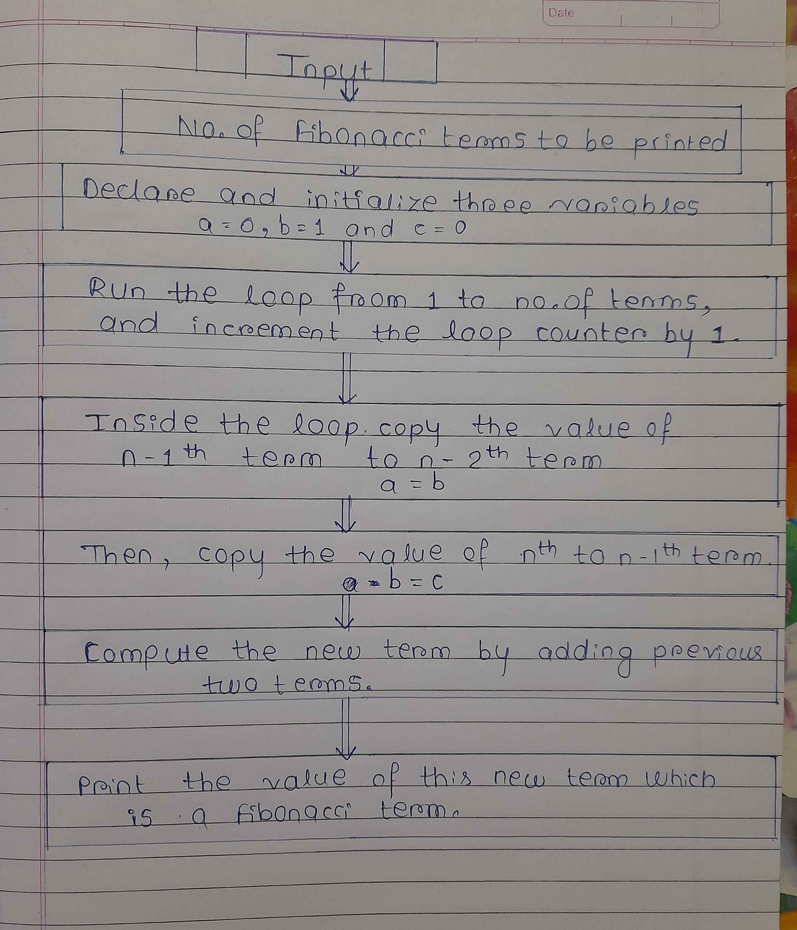

**Algorithm:**

1. Start
2. Input number of Fibonacci terms to be printed from user and store that value in a variable called ‘terms’.
3. Declare and initialize three variables, as a = 0, b = 1 and c = 0.

Where c is the current term, b is the n – 1th term and a is the

n – 2th term.

4. Run a loop from 1 to terms, increment loop counter by 1. The loop structure should look like for **( i = 1; i<= term; i++).** It will iterate through n terms.

5. Inside the loop copy the value of n – 1th term to n – 2th term that is **a = b**. Now copy the value of nth to n-1th term **b = c.**

Finally, calculate the new term by adding previous two terms

That is **c = a + b.**

6. Print the value of current Fibonacci term that is as we have defined it as **c.**

7. End.

**Program:**

#include <stdio.h>

int main()

{

int a, b, c, i, terms ;

printf("Enter no. of terms: ");

scanf("%d",&terms);

a = 0;

b = 1;

c = 0;

printf("Fibonacci series is : \n");

for(i=1;i<=terms;i++)

{

printf(“%d,”,c);

a = b;

b = c;

c = a + b;

}

printf("\nMy name is Vaidehi Mahale,\n");

printf("My roll no is 1430.");

return 0;

}

**Output:**

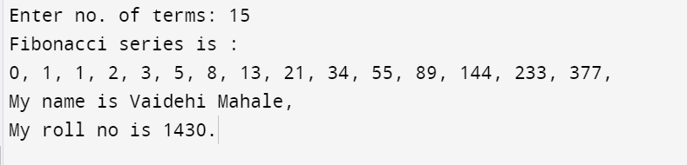

**Conclusions:**

Hence we can print Fibonacci series by making use of for loop and proper initialization of variables.